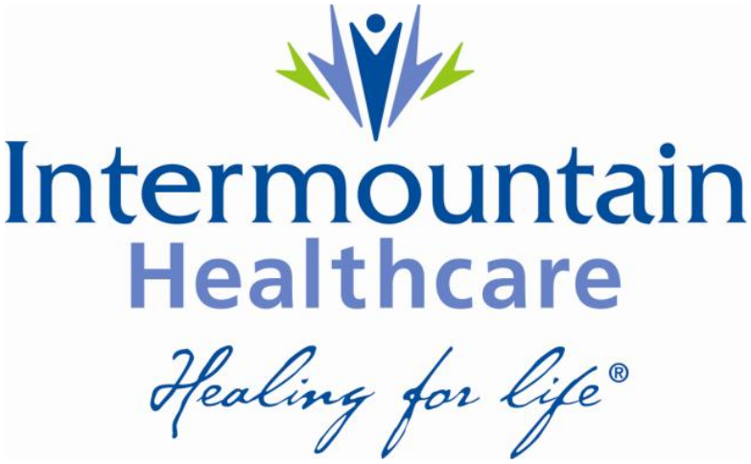

28 November 2014
Enterprise Architecture White Paper
The Role of NoSQL at Intermountain Healthcare

Johnnie Harris

Contents
Introduction 3
NoSQL Defined 3
Comparison to RDBMS 3
Risk and Benefit analysis 4
Which NoSQL solution fits best for Intermountain Healthcare 4
Conclusion 4
Appendix A 5
Appendix B 6
Index 7

Introduction

Healthcare has been slow to adopt the non-RDBMS technology that is often referred to as NoSQL. NoSQL may be referred to as “No SQL”, referring to the fact that this technology does not use the declarative language and standard called SQL. However, more commonly, the term is known as “Not only SQL” which seems to embrace the idea that this technology is a superset of the relational database.

This paper aims to describe the pros and cons of NoSQL in Healthcare and more specifically at Intermountain Healthcare.

NoSQL Defined

NoSQL is an enabling technology. It enables the managing of data generated by large-scale applications. The most common characteristics among the many different NoSQL systems are that they are schema-less, tend not to be ACID-compliant and are designed to be highly distributed.

In order to describe the pros and cons it is important to first agree to an understanding of what NoSQL is and is not. As with most popular, trending, technologies NoSQL did not start out as a standard with a well-defined vocabulary. Instead it has been shaped by the different non-RDBMS implementations which have succeeded. To this end it makes sense to understand NoSQL in terms of what has been implemented and the features that make these implementations successful and by the unique feature or features that different users find useful.

NoSQL is described as a group of progressive data management engines that go beyond legacy relational databases in order to meet the growing needs of modern business applications (Why NoSQL? Datastax Corporation, October 2013). Additional description is an engine that allows a very flexible data model, horizontal scalability, distributed architectures, and the use of languages and interfaces that are “not only” SQL – these are common characteristics of NoSQL technologies.

Comparison to RDBMS

Compare and contrast to RDBMS.

Risk and Benefit analysis

Discuss the risks and benefits. Including performance, cost, scalability, development.

Which NoSQL solution fits best for Intermountain Healthcare

Discuss the various solutions and recommend.

Conclusion
In order for us to portray something sensible in this paper, we must conclude with a summary of the details and experiences we have shared throughout this paper. We shall be sensible in our concluding statements and brevity will be our main focus. But I digress. It must be a practical summary that can be articulated and learned by those wanting to be simple.

Appendix A

This is a simple solution to a complex problem. So yada, yada, yada.

Appendix B

More appendix B stuff.

Index

No index entries found.

